Пензенский государственный университет
Кафедра «Вычислительная техника»

ОТЧЕТ
по лабораторной работе №4
по курсу «Программирование на Java»
на тему: «Работа с файлами»

Выполнили студенты группы 23ВВП1 бригады 4:
Полиневский В.В.
Кизым И.А.
Проверили:

2026
Цель работы: изучить работу с файлами и механизмы сериализации данных.
Задачи: Модифицировать приложение из предыдущей лабораторной работы, реализовав сохранение в файл и загрузку данных из файла. Предусмотреть сохранение данных, как в текстовом виде, так и в двоичном (с использованием механизма сериализации). Для этого нужно добавить 4 кнопки для сохранения и загрузки в текстовом и двоичном виде соответственно. Кроме того, в программе нужно предусмотреть использование стандартного диалога открытия файла (JFileChooser).

Практическая часть:
Листинг класса MathFunction, предназначенного для подсчета интеграла:
public class MathFunction {
private double start_unacceptability_value = Math.PI / 2;
private double step_unacceptability_period = Math.PI;
private static double EPSILON = 1e-10;
private double max_x = 0;
private double min_x = 0;
private double step = 0;
private double result;
private double next_x_position = 0;
// возвращает точный необходимый шаг
private double checking_interval_for_unacceptability(double this_x, double this_step) {
double true_next_x = this_x + this_step;
double temp_start_unacceptability_value = start_unacceptability_value;
while (true) {
if (temp_start_unacceptability_value > true_next_x){
break;
}
if (temp_start_unacceptability_value < true_next_x && temp_start_unacceptability_value > this_x) {
next_x_position = temp_start_unacceptability_value + 0.01;
return this_step - (true_next_x - temp_start_unacceptability_value) - 0.001;
}
temp_start_unacceptability_value += step_unacceptability_period;
}
while (true) {
if (temp_start_unacceptability_value < this_x){
break;
}
if (temp_start_unacceptability_value < true_next_x && temp_start_unacceptability_value > this_x) {
next_x_position = temp_start_unacceptability_value + 0.01;
return this_step - (true_next_x - temp_start_unacceptability_value) - 0.001;
}
temp_start_unacceptability_value -= step_unacceptability_period;
}
return this_step;
}
private double get_true_step(double this_x, double this_step){
double this_part_area = 0;
double temp_step = this_step;
next_x_position = this_x + temp_step;
if (this_x + this_step > max_x) {
temp_step = max_x - this_x;
next_x_position = max_x;
}
if (isUnacceptablePoint(this_x + temp_step)){
next_x_position = temp_step + this_x + 0.001;
temp_step = temp_step - 0.001;
}
temp_step = checking_interval_for_unacceptability(this_x, temp_step);
return temp_step;
}
private double mathing_part_area(double this_x, double this_step){
double this_x_plus_step = this_x + this_step;
double funtion_at_this_x = Math.sin(this_x)/Math.cos(this_x);
double function_at_this_x_plus_step = Math.sin(this_x_plus_step)/Math.cos(this_x_plus_step);
return this_step * (funtion_at_this_x + function_at_this_x_plus_step) / 2;
}
private boolean isUnacceptablePoint(double x) {
double k = (x - Math.PI/2) / Math.PI;
double nearestInteger = Math.round(k);
return Math.abs(k - nearestInteger) < EPSILON;
}
private double calculation_result(){
if (isUnacceptablePoint(min_x)) {
min_x += 0.001;
}
// проверка min_x и max_x на некоректное значение
double this_x_position = min_x;
double local_step = 0;
double result_area = 0;

while (true){
if (this_x_position == max_x ){
break;
}
local_step = get_true_step(this_x_position, step);
result_area += mathing_part_area(this_x_position, local_step);
this_x_position = next_x_position;
}
return result_area;
}

public MathFunction(double _min_x, double _max_x, double _step) {
max_x = _max_x;
min_x = _min_x;
step = _step;
}
public double get_result(){
result = calculation_result();
return result;
}
}
Листинг main класса main_window:
/*
* Click nbfs://nbhost/SystemFileSystem/Templates/Licenses/license-default.txt to change this license
* Click nbfs://nbhost/SystemFileSystem/Templates/GUIForms/JFrame.java to edit this template
*/

/**
*
* @author admin_
*/
import javax.swing.JOptionPane;
import javax.swing.table.DefaultTableModel;

public class main_window extends javax.swing.JFrame {
private ControlerTableData this_ControlerTableData;
private double last_min_x;
private double last_max_x;
private double last_step;
private int count_input_data;
private static final java.util.logging.Logger logger = java.util.logging.Logger.getLogger(main_window.class.getName());

/**
* Creates new form main_window
*/
public main_window() {
initComponents();
init_obj_ControlerTableData();
}

/**
* This method is called from within the constructor to initialize the form.
* WARNING: Do NOT modify this code. The content of this method is always
* regenerated by the Form Editor.
*/
@SuppressWarnings("unchecked")
// <editor-fold defaultstate="collapsed" desc="Generated Code">
private void initComponents() {

jPanel1 = new javax.swing.JPanel();
jLabel1 = new javax.swing.JLabel();
jPanel2 = new javax.swing.JPanel();
jLabel2 = new javax.swing.JLabel();
jLabel3 = new javax.swing.JLabel();
jLabel4 = new javax.swing.JLabel();
jTextField1 = new javax.swing.JTextField();
jTextField2 = new javax.swing.JTextField();
jTextField3 = new javax.swing.JTextField();
jButton1 = new javax.swing.JButton();
jButton2 = new javax.swing.JButton();
jButton3 = new javax.swing.JButton();
jButton4 = new javax.swing.JButton();
jButton5 = new javax.swing.JButton();
jButton7 = new javax.swing.JButton();
jButton8 = new javax.swing.JButton();
jButton9 = new javax.swing.JButton();
jButton6 = new javax.swing.JButton();
jPanel3 = new javax.swing.JPanel();
jScrollPane1 = new javax.swing.JScrollPane();
jTable1 = new javax.swing.JTable();

setDefaultCloseOperation(javax.swing.WindowConstants.EXIT_ON_CLOSE);
setBackground(new java.awt.Color(51, 0, 51));

jPanel1.setBackground(new java.awt.Color(255, 153, 255));
jPanel1.setBorder(javax.swing.BorderFactory.createBevelBorder(javax.swing.border.BevelBorder.RAISED));

jLabel1.setText("ФУНКЦИЯ: tg(x)");

javax.swing.GroupLayout jPanel1Layout = new javax.swing.GroupLayout(jPanel1);
jPanel1.setLayout(jPanel1Layout);
jPanel1Layout.setHorizontalGroup(
jPanel1Layout.createParallelGroup(javax.swing.GroupLayout.Alignment.LEADING)
.addGroup(jPanel1Layout.createSequentialGroup()
.addContainerGap()
.addComponent(jLabel1, javax.swing.GroupLayout.PREFERRED_SIZE, 156, javax.swing.GroupLayout.PREFERRED_SIZE)
.addContainerGap(javax.swing.GroupLayout.DEFAULT_SIZE, Short.MAX_VALUE))
);
jPanel1Layout.setVerticalGroup(
jPanel1Layout.createParallelGroup(javax.swing.GroupLayout.Alignment.LEADING)
.addGroup(javax.swing.GroupLayout.Alignment.TRAILING, jPanel1Layout.createSequentialGroup()
.addGap(0, 6, Short.MAX_VALUE)
.addComponent(jLabel1))
);

jPanel2.setBackground(new java.awt.Color(255, 153, 255));

jLabel2.setText("MAX x:");

jLabel3.setText("MIN x:");

jLabel4.setText("ШАГ:");

jTextField1.addActionListener(this::jTextField1ActionPerformed);

jTextField2.addActionListener(this::jTextField2ActionPerformed);

jTextField3.addActionListener(this::jTextField3ActionPerformed);

jButton1.setText("ДОБАВИТЬ");
jButton1.addActionListener(this::jButton1ActionPerformed);

jButton2.setBackground(new java.awt.Color(255, 51, 51));
jButton2.setText("УДАЛИТЬ");
jButton2.addActionListener(this::jButton2ActionPerformed);

jButton3.setBackground(new java.awt.Color(0, 204, 0));
jButton3.setText("ВЫЧИСЛИТЬ");
jButton3.addActionListener(this::jButton3ActionPerformed);

jButton4.setText("ЗАПОЛНИТЬ");
jButton4.addActionListener(this::jButton4ActionPerformed);

jButton5.setText("ОЧИСТИТЬ");
jButton5.addActionListener(this::jButton5ActionPerformed);

jButton7.setBackground(new java.awt.Color(0, 255, 255));
jButton7.setText("СОХРАНИТЬ(.dat)");
jButton7.addActionListener(this::jButton7ActionPerformed);

jButton8.setBackground(new java.awt.Color(51, 255, 255));
jButton8.setText("ЗАГРУЗИТЬ(.txt)");
jButton8.addActionListener(this::jButton8ActionPerformed);

jButton9.setBackground(new java.awt.Color(51, 255, 255));
jButton9.setText("ЗАГРУЗИТЬ(.dat)");
jButton9.addActionListener(this::jButton9ActionPerformed);

jButton6.setBackground(new java.awt.Color(102, 255, 255));
jButton6.setText("СОХРАНИТЬ(.txt)");
jButton6.addActionListener(this::jButton6ActionPerformed);

javax.swing.GroupLayout jPanel2Layout = new javax.swing.GroupLayout(jPanel2);
jPanel2.setLayout(jPanel2Layout);
jPanel2Layout.setHorizontalGroup(
jPanel2Layout.createParallelGroup(javax.swing.GroupLayout.Alignment.LEADING)
.addGroup(jPanel2Layout.createSequentialGroup()
.addContainerGap()
.addGroup(jPanel2Layout.createParallelGroup(javax.swing.GroupLayout.Alignment.LEADING, false)
.addComponent(jLabel2, javax.swing.GroupLayout.DEFAULT_SIZE, javax.swing.GroupLayout.DEFAULT_SIZE, Short.MAX_VALUE)
.addComponent(jLabel3, javax.swing.GroupLayout.DEFAULT_SIZE, javax.swing.GroupLayout.DEFAULT_SIZE, Short.MAX_VALUE)
.addComponent(jLabel4, javax.swing.GroupLayout.DEFAULT_SIZE, javax.swing.GroupLayout.DEFAULT_SIZE, Short.MAX_VALUE))
.addPreferredGap(javax.swing.LayoutStyle.ComponentPlacement.UNRELATED)
.addGroup(jPanel2Layout.createParallelGroup(javax.swing.GroupLayout.Alignment.LEADING, false)
.addComponent(jTextField1, javax.swing.GroupLayout.DEFAULT_SIZE, 111, Short.MAX_VALUE)
.addComponent(jTextField2)
.addComponent(jTextField3))
.addPreferredGap(javax.swing.LayoutStyle.ComponentPlacement.RELATED, javax.swing.GroupLayout.DEFAULT_SIZE, Short.MAX_VALUE)
.addGroup(jPanel2Layout.createParallelGroup(javax.swing.GroupLayout.Alignment.LEADING, false)
.addGroup(javax.swing.GroupLayout.Alignment.TRAILING, jPanel2Layout.createSequentialGroup()
.addComponent(jButton6, javax.swing.GroupLayout.DEFAULT_SIZE, javax.swing.GroupLayout.DEFAULT_SIZE, Short.MAX_VALUE)
.addGap(18, 18, 18)
.addComponent(jButton8, javax.swing.GroupLayout.PREFERRED_SIZE, 150, javax.swing.GroupLayout.PREFERRED_SIZE))
.addGroup(javax.swing.GroupLayout.Alignment.TRAILING, jPanel2Layout.createSequentialGroup()
.addComponent(jButton4)
.addGap(18, 18, 18)
.addComponent(jButton5, javax.swing.GroupLayout.PREFERRED_SIZE, 120, javax.swing.GroupLayout.PREFERRED_SIZE))
.addGroup(javax.swing.GroupLayout.Alignment.TRAILING, jPanel2Layout.createSequentialGroup()
.addComponent(jButton7)
.addPreferredGap(javax.swing.LayoutStyle.ComponentPlacement.UNRELATED)
.addComponent(jButton9, javax.swing.GroupLayout.PREFERRED_SIZE, 155, javax.swing.GroupLayout.PREFERRED_SIZE)))
.addPreferredGap(javax.swing.LayoutStyle.ComponentPlacement.UNRELATED)
.addGroup(jPanel2Layout.createParallelGroup(javax.swing.GroupLayout.Alignment.LEADING)
.addComponent(jButton3)
.addGroup(jPanel2Layout.createParallelGroup(javax.swing.GroupLayout.Alignment.LEADING)
.addComponent(jButton1, javax.swing.GroupLayout.Alignment.TRAILING, javax.swing.GroupLayout.PREFERRED_SIZE, 124, javax.swing.GroupLayout.PREFERRED_SIZE)
.addComponent(jButton2, javax.swing.GroupLayout.PREFERRED_SIZE, 124, javax.swing.GroupLayout.PREFERRED_SIZE)))
.addContainerGap())
);
jPanel2Layout.setVerticalGroup(
jPanel2Layout.createParallelGroup(javax.swing.GroupLayout.Alignment.LEADING)
.addGroup(jPanel2Layout.createSequentialGroup()
.addContainerGap()
.addGroup(jPanel2Layout.createParallelGroup(javax.swing.GroupLayout.Alignment.LEADING, false)
.addComponent(jLabel2, javax.swing.GroupLayout.DEFAULT_SIZE, javax.swing.GroupLayout.DEFAULT_SIZE, Short.MAX_VALUE)
.addGroup(jPanel2Layout.createParallelGroup(javax.swing.GroupLayout.Alignment.BASELINE)
.addComponent(jTextField1, javax.swing.GroupLayout.PREFERRED_SIZE, javax.swing.GroupLayout.DEFAULT_SIZE, javax.swing.GroupLayout.PREFERRED_SIZE)
.addComponent(jButton4)
.addComponent(jButton1)
.addComponent(jButton5)))
.addGroup(jPanel2Layout.createParallelGroup(javax.swing.GroupLayout.Alignment.LEADING)
.addGroup(jPanel2Layout.createSequentialGroup()
.addGap(6, 6, 6)
.addGroup(jPanel2Layout.createParallelGroup(javax.swing.GroupLayout.Alignment.LEADING)
.addGroup(jPanel2Layout.createParallelGroup(javax.swing.GroupLayout.Alignment.BASELINE)
.addComponent(jButton2)
.addComponent(jButton8)
.addComponent(jButton6))
.addComponent(jLabel3))
.addGap(6, 6, 6))
.addGroup(javax.swing.GroupLayout.Alignment.TRAILING, jPanel2Layout.createSequentialGroup()
.addPreferredGap(javax.swing.LayoutStyle.ComponentPlacement.RELATED)
.addComponent(jTextField2, javax.swing.GroupLayout.PREFERRED_SIZE, javax.swing.GroupLayout.DEFAULT_SIZE, javax.swing.GroupLayout.PREFERRED_SIZE)))
.addGroup(jPanel2Layout.createParallelGroup(javax.swing.GroupLayout.Alignment.LEADING)
.addGroup(jPanel2Layout.createSequentialGroup()
.addGroup(jPanel2Layout.createParallelGroup(javax.swing.GroupLayout.Alignment.LEADING)
.addGroup(jPanel2Layout.createParallelGroup(javax.swing.GroupLayout.Alignment.BASELINE)
.addComponent(jLabel4)
.addComponent(jButton3))
.addGroup(jPanel2Layout.createSequentialGroup()
.addPreferredGap(javax.swing.LayoutStyle.ComponentPlacement.RELATED)
.addGroup(jPanel2Layout.createParallelGroup(javax.swing.GroupLayout.Alignment.LEADING)
.addComponent(jButton9)
.addComponent(jButton7))))
.addContainerGap(javax.swing.GroupLayout.DEFAULT_SIZE, Short.MAX_VALUE))
.addGroup(javax.swing.GroupLayout.Alignment.TRAILING, jPanel2Layout.createSequentialGroup()
.addPreferredGap(javax.swing.LayoutStyle.ComponentPlacement.RELATED, javax.swing.GroupLayout.DEFAULT_SIZE, Short.MAX_VALUE)
.addComponent(jTextField3, javax.swing.GroupLayout.PREFERRED_SIZE, javax.swing.GroupLayout.DEFAULT_SIZE, javax.swing.GroupLayout.PREFERRED_SIZE)
.addGap(15, 15, 15))))
);

jPanel3.setBackground(new java.awt.Color(255, 153, 255));

jTable1.setAutoCreateRowSorter(true);
jTable1.setBorder(javax.swing.BorderFactory.createLineBorder(new java.awt.Color(0, 0, 0)));
jTable1.setModel(new javax.swing.table.DefaultTableModel(
new Object [][] {
{null, null, null, null, null},
{null, null, null, null, null},
{null, null, null, null, null},
{null, null, null, null, null},
{null, null, null, null, null},
{null, null, null, null, null},
{null, null, null, null, null},
{null, null, null, null, null},
{null, null, null, null, null},
{null, null, null, null, null},
{null, null, null, null, null},
{null, null, null, null, null},
{null, null, null, null, null},
{null, null, null, null, null},
{null, null, null, null, null},
{null, null, null, null, null},
{null, null, null, null, null},
{null, null, null, null, null},
{null, null, null, null, null},
{null, null, null, null, null}
},
new String [] {
"N", "MAX X", "MIN Y", "ШАГ", "РЕЗУЛЬТАТ"
}
));
jTable1.setPreferredSize(new java.awt.Dimension(320, 447));
jScrollPane1.setViewportView(jTable1);
if (jTable1.getColumnModel().getColumnCount() > 0) {
jTable1.getColumnModel().getColumn(0).setPreferredWidth(5);
}

javax.swing.GroupLayout jPanel3Layout = new javax.swing.GroupLayout(jPanel3);
jPanel3.setLayout(jPanel3Layout);
jPanel3Layout.setHorizontalGroup(
jPanel3Layout.createParallelGroup(javax.swing.GroupLayout.Alignment.LEADING)
.addGroup(javax.swing.GroupLayout.Alignment.TRAILING, jPanel3Layout.createSequentialGroup()
.addContainerGap(52, Short.MAX_VALUE)
.addComponent(jScrollPane1, javax.swing.GroupLayout.PREFERRED_SIZE, 552, javax.swing.GroupLayout.PREFERRED_SIZE)
.addGap(38, 38, 38))
);
jPanel3Layout.setVerticalGroup(
jPanel3Layout.createParallelGroup(javax.swing.GroupLayout.Alignment.LEADING)
.addGroup(jPanel3Layout.createSequentialGroup()
.addContainerGap()
.addComponent(jScrollPane1, javax.swing.GroupLayout.PREFERRED_SIZE, 475, javax.swing.GroupLayout.PREFERRED_SIZE)
.addContainerGap(24, Short.MAX_VALUE))
);

javax.swing.GroupLayout layout = new javax.swing.GroupLayout(getContentPane());
getContentPane().setLayout(layout);
layout.setHorizontalGroup(
layout.createParallelGroup(javax.swing.GroupLayout.Alignment.LEADING)
.addComponent(jPanel1, javax.swing.GroupLayout.DEFAULT_SIZE, javax.swing.GroupLayout.DEFAULT_SIZE, Short.MAX_VALUE)
.addComponent(jPanel2, javax.swing.GroupLayout.DEFAULT_SIZE, javax.swing.GroupLayout.DEFAULT_SIZE, Short.MAX_VALUE)
.addGroup(layout.createSequentialGroup()
.addComponent(jPanel3, javax.swing.GroupLayout.DEFAULT_SIZE, javax.swing.GroupLayout.DEFAULT_SIZE, Short.MAX_VALUE)
.addContainerGap())
);
layout.setVerticalGroup(
layout.createParallelGroup(javax.swing.GroupLayout.Alignment.LEADING)
.addGroup(layout.createSequentialGroup()
.addComponent(jPanel1, javax.swing.GroupLayout.PREFERRED_SIZE, javax.swing.GroupLayout.DEFAULT_SIZE, javax.swing.GroupLayout.PREFERRED_SIZE)
.addPreferredGap(javax.swing.LayoutStyle.ComponentPlacement.RELATED)
.addComponent(jPanel2, javax.swing.GroupLayout.PREFERRED_SIZE, javax.swing.GroupLayout.DEFAULT_SIZE, javax.swing.GroupLayout.PREFERRED_SIZE)
.addPreferredGap(javax.swing.LayoutStyle.ComponentPlacement.RELATED)
.addComponent(jPanel3, javax.swing.GroupLayout.PREFERRED_SIZE, javax.swing.GroupLayout.DEFAULT_SIZE, javax.swing.GroupLayout.PREFERRED_SIZE)
.addContainerGap())
);

pack();
}// </editor-fold>

private void jTextField1ActionPerformed(java.awt.event.ActionEvent evt) {
// TODO add your handling code here:
}

private void jTextField2ActionPerformed(java.awt.event.ActionEvent evt) {
// TODO add your handling code here:
}

private void jTextField3ActionPerformed(java.awt.event.ActionEvent evt) {
// TODO add your handling code here:
}
//инициализация поля класса this_ControlerTableData, выступающего интерфейсом над данными таблицы
private void init_obj_ControlerTableData() {
DefaultTableModel model_table = (DefaultTableModel) jTable1.getModel();
this_ControlerTableData = new ControlerTableData(model_table);
}
// обработка клика на кнопку: вычислить
private void jButton3ActionPerformed(java.awt.event.ActionEvent evt) {
int rowIndex = jTable1.getSelectedRow();
if (rowIndex == -1) {
JOptionPane.showMessageDialog(this, "строка не выбрана");
return;
}
this_ControlerTableData.show_integral_at_index(rowIndex);
return;
}
// обработка клика на кнопку: добавить
private void jButton1ActionPerformed(java.awt.event.ActionEvent evt) {
DefaultTableModel model_table = (DefaultTableModel) jTable1.getModel();
if (model_table.getRowCount() > 0 && model_table.getValueAt(0, 0) == null) {
model_table.setRowCount(0);
}
String string_max_x = jTextField1.getText();
String string_min_x = jTextField2.getText();
String string_step = jTextField3.getText();
if (string_max_x.isEmpty() || string_min_x.isEmpty() || string_step.isEmpty()) {
JOptionPane.showConfirmDialog(this, "Заполните все поля");
return;
}
double double_max_x = Double.parseDouble(string_max_x);
double double_min_x = Double.parseDouble(string_min_x);
double double_step = Double.parseDouble(string_step);
try {
this_ControlerTableData.push_back_input_data(double_max_x, double_min_x, double_step);
}
catch (InputValueException exc) {
JOptionPane.showConfirmDialog(this, exc.get_exc_message() + Double.toString(exc.get_ex_value()));
}
jTable1.repaint();
jTable1.revalidate();
count_input_data++;
return;
}
// обработка клика на кнопку: удалить
private void jButton2ActionPerformed(java.awt.event.ActionEvent evt) {
int rowIndex = jTable1.getSelectedRow();
if (rowIndex == -1) {
JOptionPane.showMessageDialog(this, "строка не выбрана");
return;
}
this_ControlerTableData.remove_row_at_index(rowIndex);
return;
}
// обработка клика на кнопку: заполнить
private void jButton4ActionPerformed(java.awt.event.ActionEvent evt) {
this_ControlerTableData.clear_table_data();
this_ControlerTableData.show_all_data_rows();
}
// обрабокта клика на кнопку: очистить
private void jButton5ActionPerformed(java.awt.event.ActionEvent evt) {
this_ControlerTableData.clear_table_data();
}
// обработка клика на кнопку: сохранить(.dat)
private void jButton7ActionPerformed(java.awt.event.ActionEvent evt) {
boolean flag_show_exit_info = true;
try {
this_ControlerTableData.write_table_data_in_bin_file();
}
catch (OpenSaveFileException exc) {
JOptionPane.showConfirmDialog(this, exc.get_name_function_with_exc() + exc.get_file_path_exc() + exc.get_msg_decision());
flag_show_exit_info = false;
}
if (flag_show_exit_info) {
JOptionPane.showConfirmDialog(this, "Данные успешно сохранены");
}
// TODO add your handling code here:
}
// обработка клика на кнопку загрузить(.txt)
private void jButton8ActionPerformed(java.awt.event.ActionEvent evt) {
boolean flag_show_exit_info = true;
try {
this_ControlerTableData.download_table_data_from_text_file();
}
catch (OpenSaveFileException exc) {
JOptionPane.showConfirmDialog(this, exc.get_name_function_with_exc() + exc.get_file_path_exc() + exc.get_msg_decision());
flag_show_exit_info = false;
}
if (flag_show_exit_info) {
JOptionPane.showConfirmDialog(this, "Данные успешно загружены");
}
// TODO add your handling code here:
}
// обработка клика на кнопку: сохранить(.txt)
private void jButton6ActionPerformed(java.awt.event.ActionEvent evt) {
boolean flag_show_exit_info = true;
try {
this_ControlerTableData.write_table_data_in_text_file();
}
catch (OpenSaveFileException exc) {
flag_show_exit_info = false;
JOptionPane.showConfirmDialog(this, exc.get_name_function_with_exc() + exc.get_file_path_exc() + exc.get_msg_decision());
}
if (flag_show_exit_info) {
JOptionPane.showConfirmDialog(this, "Данные успешно сохранены");
}
// TODO add your handling code here:
}
// обрабокта клика на кнопку: загрузить (.dat)
private void jButton9ActionPerformed(java.awt.event.ActionEvent evt) {
boolean flag_show_exit_info = true;
try {
this_ControlerTableData.download_table_data_from_bin_file();
}
catch (OpenSaveFileException exc) {
flag_show_exit_info = false;
JOptionPane.showConfirmDialog(this, exc.get_name_function_with_exc() + exc.get_file_path_exc() + exc.get_msg_decision());
}
if (flag_show_exit_info) {
JOptionPane.showConfirmDialog(this, "Данные успешно загружены");
}
}

/**
* @param args the command line arguments
*/
public static void main(String args[]) {
/* Set the Nimbus look and feel */
//<editor-fold defaultstate="collapsed" desc=" Look and feel setting code (optional) ">
/* If Nimbus (introduced in Java SE 6) is not available, stay with the default look and feel.
* For details see http://download.oracle.com/javase/tutorial/uiswing/lookandfeel/plaf.html
*/
try {
for (javax.swing.UIManager.LookAndFeelInfo info : javax.swing.UIManager.getInstalledLookAndFeels()) {
if ("Nimbus".equals(info.getName())) {
javax.swing.UIManager.setLookAndFeel(info.getClassName());
break;
}
}
} catch (ReflectiveOperationException | javax.swing.UnsupportedLookAndFeelException ex) {
logger.log(java.util.logging.Level.SEVERE, null, ex);
}
//</editor-fold>

/* Create and display the form */
java.awt.EventQueue.invokeLater(() -> new main_window().setVisible(true));
}
// Variables declaration - do not modify
private javax.swing.JButton jButton1;
private javax.swing.JButton jButton2;
private javax.swing.JButton jButton3;
private javax.swing.JButton jButton4;
private javax.swing.JButton jButton5;
private javax.swing.JButton jButton6;
private javax.swing.JButton jButton7;
private javax.swing.JButton jButton8;
private javax.swing.JButton jButton9;
private javax.swing.JLabel jLabel1;
private javax.swing.JLabel jLabel2;
private javax.swing.JLabel jLabel3;
private javax.swing.JLabel jLabel4;
private javax.swing.JPanel jPanel1;
private javax.swing.JPanel jPanel2;
private javax.swing.JPanel jPanel3;
private javax.swing.JScrollPane jScrollPane1;
private javax.swing.JTable jTable1;
private javax.swing.JTextField jTextField1;
private javax.swing.JTextField jTextField2;
private javax.swing.JTextField jTextField3;
// End of variables declaration
}

Листинг класса RecIntegral, реалзиующего функционал сущности одной записи таблицы:
/*
* Click nbfs://nbhost/SystemFileSystem/Templates/Licenses/license-default.txt to change this license
* Click nbfs://nbhost/SystemFileSystem/Templates/Classes/Class.java to edit this template
*/

/**
*
* @author admin_
*/
import java.io.Serializable;
public class RecIntegral implements Serializable{
private long serialVersionUID = 1L;
private double max_x = 0.0;
private double min_x = 0.0;
private double step = 0.0;
private double integral = 0.0;

boolean flag_prev_mathing = false;

public RecIntegral(double _max_x, double _min_x, double _step) {
max_x = _max_x;
min_x = _min_x;
step = _step;
}
public RecIntegral(double _max_x, double _min_x, double _step, double _integral){
max_x = _max_x;
min_x = _min_x;
step = _step;
integral = _integral;
flag_prev_mathing = true;
}
public double get_integral() {
if (flag_prev_mathing == false) {
MathFunction obj_MathFunction = new MathFunction(min_x, max_x, step);
integral = obj_MathFunction.get_result();
flag_prev_mathing = true;
}
return integral;
}
public double get_max_x(){return max_x;}
public double get_min_x(){return min_x;}
public double get_step(){return step;}

}
Листинг класса ControlerTableData, реализующего функционал интерфейса над таблицей, и колекцией объектов LinkedList:
/*
* Click nbfs://nbhost/SystemFileSystem/Templates/Licenses/license-default.txt to change this license
* Click nbfs://nbhost/SystemFileSystem/Templates/Classes/Class.java to edit this template
*/

/**
*
* @author admin_
*/
import javax.swing.table.DefaultTableModel;
import java.util.LinkedList;
import java.io.FileReader;
import java.io.FileWriter;
import javax.swing.JFileChooser;
import java.io.File;

public class ControlerTableData {
private String basic_path_dir = "/home/admin_/Документы";
private DefaultTableModel table_model;
private LinkedList <RecIntegral> LinkedListRecIntegral;

private int check_correctness_fname_for_save_bin_file(String f_name, String local_absolute_f_path, String added_msg) {
return 0;
}
public ControlerTableData(DefaultTableModel _table_model){
table_model = _table_model;
LinkedListRecIntegral = new LinkedList <RecIntegral> ();
}
public void remove_last(){
if (LinkedListRecIntegral.size() > 0) {
table_model.removeRow(LinkedListRecIntegral.size() - 1);
LinkedListRecIntegral.removeLast();
}
return;
}
public void remove_row_at_index(int index_Row) {
table_model.removeRow(index_Row);
LinkedListRecIntegral.remove(index_Row);
}

public boolean check_invalid_value (double value_double) {
if (value_double < 0.000001 || value_double > 1000000.0) {return true;}
return false;
}

public void show_all_data_rows(){
table_model.setRowCount(0);
for (int i = 0; i < LinkedListRecIntegral.size(); i++) {
double local_max_x = LinkedListRecIntegral.get(i).get_max_x();
double local_min_x = LinkedListRecIntegral.get(i).get_min_x();
double local_step = LinkedListRecIntegral.get(i).get_step();
double local_integral = LinkedListRecIntegral.get(i).get_integral();
table_model.addRow(new Object []{i + 1,local_max_x,local_min_x,local_step,local_integral});
table_model.fireTableDataChanged();
}
table_model.fireTableDataChanged();
return;
}
public void clear_table_data() {
table_model.setRowCount(0);
return;
}
public void show_last_integral(){
double local_integral = LinkedListRecIntegral.getLast().get_integral();
table_model.setValueAt(local_integral, LinkedListRecIntegral.size()-1,4);
}
public void show_integral_at_index(int indexRow){
double local_integral = LinkedListRecIntegral.get(indexRow).get_integral();
table_model.setValueAt(local_integral, indexRow, 4);
}
public void push_back_input_data(double max_x, double min_x, double step) throws InputValueException{
if (check_invalid_value(max_x)){throw new InputValueException("Uncorectable max_x value:" , max_x);}
if (check_invalid_value(min_x)){throw new InputValueException("Uncorectable min_x value: ", min_x);}
if (check_invalid_value(step)){throw new InputValueException("Uncorectable step value: ", step);}
if (max_x < min_x) {throw new InputValueException("min_x > max_x, min_x: ", min_x);}
if (step > max_x - min_x ) {throw new InputValueException("step > dif max_x and min_x, step: ", step);}
RecIntegral obj_RecIntegral = new RecIntegral(max_x, min_x, step);
LinkedListRecIntegral.add(obj_RecIntegral);
table_model.addRow(new Object []{LinkedListRecIntegral.size(),max_x,min_x,step, null});
}
// функция записи данных таблицы в текстовый файл
public void write_table_data_in_text_file() throws OpenSaveFileException{
if (LinkedListRecIntegral.size() == 0) {throw new OpenSaveFileException("write_table_data_in_text_file-> ", "Путь к файлу не задан. ", "Таблица пуста, нечего сохранять. ");}
JFileChooser chooser_window = new JFileChooser(basic_path_dir);
int result_operation = chooser_window.showSaveDialog(null);
if (result_operation == JFileChooser.APPROVE_OPTION) {
File selected_file = chooser_window.getSelectedFile();
String absolute_path = selected_file.getAbsolutePath();
String local_file_name = selected_file.getName();
CheckCorrecntessFileName obj_CheckCorrecntessFileName = new CheckCorrecntessFileName(absolute_path, local_file_name);
int result_correctness_fname = obj_CheckCorrecntessFileName.check_correctness_fname_for_save_text_file();
String mes_added_info = obj_CheckCorrecntessFileName.get_added_msg();

if (result_correctness_fname == 1) {throw new OpenSaveFileException("CHECKCORRECTNTESSFILENAME-> ", absolute_path, " # Введенное вами имя файла является пустым. Пример имени файла : out.txt #");}
if (result_correctness_fname == 2) {throw new OpenSaveFileException("CHECKCORRECTNTESSFILENAME-> ", absolute_path, " # В веденном вами имени файла отсуствует расширение. Пример имени файла : out.txt #");}
if (result_correctness_fname == 3) {throw new OpenSaveFileException("CHECKCORRECTNTESSFILENAME-> ", absolute_path, " # В веденном вами имени файла расширение указано неправильно: " + mes_added_info + " вместо txt. Пример имени файла : out.txt #");}
if (result_correctness_fname == 4) {throw new OpenSaveFileException("CHECKCORRECTNTESSFILENAME-> ", absolute_path, " # В веденном вами имени файла присутсвует запрещенный символ: " + mes_added_info + " . Пример имени файла: out.txt #");}
if (result_correctness_fname == 5) {throw new OpenSaveFileException("CHECKCORRECTNTESSFILENAME-> ", absolute_path, " # Имя с введенным вами именем уже существует. Попробуйте ввести другое. #");}

OperationFile this_OperationFile = new OperationFile(absolute_path);
try {
this_OperationFile.write_table_data_in_text_file(LinkedListRecIntegral);
}
catch (OpenSaveFileException exc) {
throw exc;
}
}
return;
}
// функция записи данных таблицы в бинарный файл
public void write_table_data_in_bin_file() throws OpenSaveFileException{
if (LinkedListRecIntegral.size() == 0) {throw new OpenSaveFileException("write_table_data_in_text_file-> ", "Путь к файлу не задан. ", "Таблица пуста, нечего сохранять. ");}
JFileChooser chooser_window = new JFileChooser(basic_path_dir);
int result_operation = chooser_window.showSaveDialog(null);
if (result_operation == JFileChooser.APPROVE_OPTION) {
File selected_file = chooser_window.getSelectedFile();
String absolute_path = selected_file.getAbsolutePath();
String local_file_name = selected_file.getName();
CheckCorrecntessFileName obj_CheckCorrecntessFileName = new CheckCorrecntessFileName(absolute_path, local_file_name);
int result_correctness_fname = obj_CheckCorrecntessFileName.check_correctness_fname_for_save_bin_file();
String mes_added_info = obj_CheckCorrecntessFileName.get_added_msg();

if (result_correctness_fname == 1) {throw new OpenSaveFileException("CHECKCORRECTNTESSFILENAME-> ", absolute_path, " # Введенное вами имя файла является пустым. Пример имени файла : out.dat #");}
if (result_correctness_fname == 2) {throw new OpenSaveFileException("CHECKCORRECTNTESSFILENAME-> ", absolute_path, " # В веденном вами имени файла отсуствует расширение. Пример имени файла : out.dat #");}
if (result_correctness_fname == 3) {throw new OpenSaveFileException("CHECKCORRECTNTESSFILENAME-> ", absolute_path, " # В веденном вами имени файла расширение указано неправильно: " + mes_added_info + " вместо .dat. Пример имени файла : out.dat #");}
if (result_correctness_fname == 4) {throw new OpenSaveFileException("CHECKCORRECTNTESSFILENAME-> ", absolute_path, " # В веденном вами имени файла присутсвует запрещенный символ: " + mes_added_info + " . Пример имени файла: out.dat #");}
if (result_correctness_fname == 5) {throw new OpenSaveFileException("CHECKCORRECTNTESSFILENAME-> ", absolute_path, " # Имя с введенным вами именем уже существует. Попробуйте ввести другое. #");}

OperationFile this_OperationFile = new OperationFile(absolute_path);
try {
this_OperationFile.write_table_data_in_bin_file(LinkedListRecIntegral);
}
catch (OpenSaveFileException exc) {
throw exc;
}
}
return;
}
// функция получения данных таблицы из текстового файла
public void download_table_data_from_text_file() throws OpenSaveFileException{
JFileChooser chooser_window = new JFileChooser(basic_path_dir);
int result_operation = chooser_window.showOpenDialog(null);
if (result_operation == JFileChooser.APPROVE_OPTION){
File selected_file = chooser_window.getSelectedFile();
String absolute_path = selected_file.getAbsolutePath();
String local_file_name = selected_file.getName();
CheckCorrecntessFileName obj_CheckCorrecntessFileName = new CheckCorrecntessFileName(absolute_path, local_file_name);
int result_correctness_fname = obj_CheckCorrecntessFileName.check_correctness_fname_for_download_from_text_file();
String mes_added_info = obj_CheckCorrecntessFileName.get_added_msg();

if (result_correctness_fname == 1) {throw new OpenSaveFileException("CHECKCORRECTNTESSFILENAME-> ", absolute_path, " # Введенное вами имя файла является пустым. Пример имени файла : out.txt #");}
if (result_correctness_fname == 2) {throw new OpenSaveFileException("CHECKCORRECTNTESSFILENAME-> ", absolute_path, " # В веденном вами имени файла отсуствует расширение. Пример имени файла : out.txt #");}
if (result_correctness_fname == 3) {throw new OpenSaveFileException("CHECKCORRECTNTESSFILENAME-> ", absolute_path, " # В веденном вами имени файла расширение указано неправильно: " + mes_added_info + " вместо txt. Пример имени файла : out.txt #");}
if (result_correctness_fname == 4) {throw new OpenSaveFileException("CHECKCORRECTNTESSFILENAME-> ", absolute_path, " # В веденном вами имени файла присутсвует запрещенный символ: " + mes_added_info + " . Пример имени файла: out.txt #");}
if (result_correctness_fname == 5) {throw new OpenSaveFileException("CHECKCORRECTNTESSFILENAME-> ", absolute_path, " # Имя с введенным вами именем не существует. Попробуйте ввести другое. #");}

OperationFile this_OperationFile = new OperationFile(absolute_path);
LinkedList <RecIntegral> local_LinkedList;
try {
local_LinkedList = this_OperationFile.get_table_data_from_text_file();
}
catch (OpenSaveFileException exc) {
throw exc;
}
for (int i = 0; i < local_LinkedList.size(); i++ ) {
LinkedListRecIntegral.add(local_LinkedList.get(i));
}
clear_table_data();
show_all_data_rows();
}
}
// функция получения данных таблицы из бинарного файла
public void download_table_data_from_bin_file() throws OpenSaveFileException{
JFileChooser chooser_window = new JFileChooser(basic_path_dir);
int result_operation = chooser_window.showOpenDialog(null);
if (result_operation == JFileChooser.APPROVE_OPTION){
File selected_file = chooser_window.getSelectedFile();
String absolute_path = selected_file.getAbsolutePath();
String local_file_name = selected_file.getName();
CheckCorrecntessFileName obj_CheckCorrecntessFileName = new CheckCorrecntessFileName(absolute_path, local_file_name);
int result_correctness_fname = obj_CheckCorrecntessFileName.check_correctness_fname_for_download_from_bin_file();
String mes_added_info = obj_CheckCorrecntessFileName.get_added_msg();

if (result_correctness_fname == 1) {throw new OpenSaveFileException("CHECKCORRECTNTESSFILENAME-> ", absolute_path, " # Введенное вами имя файла является пустым. Пример имени файла : out.dat #");}
if (result_correctness_fname == 2) {throw new OpenSaveFileException("CHECKCORRECTNTESSFILENAME-> ", absolute_path, " # В веденном вами имени файла отсуствует расширение. Пример имени файла : out.dat #");}
if (result_correctness_fname == 3) {throw new OpenSaveFileException("CHECKCORRECTNTESSFILENAME-> ", absolute_path, " # В веденном вами имени файла расширение указано неправильно: " + mes_added_info + " вместо .dat .Пример имени файла : out.dat #");}
if (result_correctness_fname == 4) {throw new OpenSaveFileException("CHECKCORRECTNTESSFILENAME-> ", absolute_path, " # В веденном вами имени файла присутсвует запрещенный символ: " + mes_added_info + " . Пример имени файла: out.dat #");}
if (result_correctness_fname == 5) {throw new OpenSaveFileException("CHECKCORRECTNTESSFILENAME-> ", absolute_path, " # Имя с введенным вами именем не существует. Попробуйте ввести другое. #");}

LinkedList <RecIntegral> local_LinkedList;
OperationFile this_OperationFile = new OperationFile(absolute_path);
try {
local_LinkedList = this_OperationFile.get_table_data_from_bin_file();
}
catch (OpenSaveFileException exc) {
throw exc;
}
for (int i = 0; i < local_LinkedList.size(); i++ ) {
LinkedListRecIntegral.add(local_LinkedList.get(i));
}
clear_table_data();
show_all_data_rows();
}
}
}

Листинг класса InputValueException, унаследованного от Exception и являющегося классом исключения для некоректного значения числа.
public class InputValueException extends Exception {
private String exc_message = "";
private double ex_double_value;
public InputValueException (String ex_mes, double ex_val) {
exc_message = ex_mes;
ex_double_value = ex_val;
}
public String get_exc_message () {return exc_message;}
public double get_ex_value() {return ex_double_value;}
}
Листинг класса OperationFile, реализующего функционал записи и считывания информации из файла:
import java.util.LinkedList;

/*
* Click nbfs://nbhost/SystemFileSystem/Templates/Licenses/license-default.txt to change this license
* Click nbfs://nbhost/SystemFileSystem/Templates/Classes/Class.java to edit this template
*/

/**
*
* @author admin_
*/
import java.io.File;
import java.io.FileReader;
import java.io.FileWriter;
import java.io.IOException;
import java.io.BufferedReader;
import java.io.ObjectOutputStream;
import java.io.FileOutputStream;
import java.io.ObjectInputStream;
import java.io.FileInputStream;

public class OperationFile {
private String header_line = "file_with_table_data\n";
private String header_line_without_space = "file_with_table_data";
private String file_absolute_path = "";
private boolean flag_bin_file = false;
private void parsing_text_line(String Line, double _max_x, double _min_x, double _step, double _integral) {

}
public OperationFile(String _file_absolute_path){file_absolute_path = _file_absolute_path;}

public LinkedList <RecIntegral> get_table_data_from_text_file() throws OpenSaveFileException {
LinkedList <RecIntegral> LinkedListRecIntegral;
ParsingDataString this_ParsingDataString;
File this_file = new File(file_absolute_path);
FileWriter this_file_writer;
boolean result_creating = false;
String line = "";
double this_max_x;
double this_min_x;
double this_step;
double this_integral;
try {
if (!this_file.isFile()) {throw new OpenSaveFileException("OPERATIONFILE.get_table_data_from_text_file-> ", file_absolute_path, " # Файл не существует #");}
FileReader this_FileReader = new FileReader(this_file);
BufferedReader this_BufferedReader = new BufferedReader(this_FileReader);
line = this_BufferedReader.readLine();
if (line == null || line.isEmpty()) {}
if (!line.equals(header_line_without_space)) {throw new OpenSaveFileException("OPERATIONFILE.get_table_data_from_text_file-> ",file_absolute_path, " # Данный файл не является файлом, сохраненным через это приложение #");}
LinkedListRecIntegral = new LinkedList <RecIntegral> ();
while (true) {
line = this_BufferedReader.readLine();
if (line == null) {break;}
this_ParsingDataString = new ParsingDataString(line);
int result = this_ParsingDataString.calculating_DataRowValue_from_textString();
if (result == 1) {throw new OpenSaveFileException("PASINGDATASTRING.calculating_DataRowValue_from_textString-> ", file_absolute_path, " # В файле найдена некоректная строка с данными #");}
this_max_x = this_ParsingDataString.get_max_x();
this_min_x = this_ParsingDataString.get_min_x();
this_step = this_ParsingDataString.get_step();
this_integral = this_ParsingDataString.get_integral();
RecIntegral temp_RecIntegral = new RecIntegral(this_max_x, this_min_x, this_step, this_integral);
LinkedListRecIntegral.add(temp_RecIntegral);
}
}
catch (IOException exc) {
throw new OpenSaveFileException("OPERATIONFILE.get_table_data_from_text_file-> ", file_absolute_path, " # Возникла ошибка непосредсвенно связанная с FileReader #");
}
return LinkedListRecIntegral;
}
public LinkedList <RecIntegral> get_table_data_from_bin_file() throws OpenSaveFileException {
LinkedList <RecIntegral> LinkedListRecIntegral;
LinkedListRecIntegral = new LinkedList <RecIntegral> ();
try {
ObjectInputStream this_ObjectInputStream = new ObjectInputStream(new FileInputStream(file_absolute_path));
String prev_line = this_ObjectInputStream.readUTF();
if (!prev_line.equals(header_line)) {throw new OpenSaveFileException("OPERATIONFILE.get_table_data_from_bin_file-> ", file_absolute_path, " # Данный файл не является файлом, сохраненным через это приложение # ");}
int version = this_ObjectInputStream.readInt();
int size = this_ObjectInputStream.readInt();
for (int i = 0; i < size ; i++) {
RecIntegral obj_RecIntegral = (RecIntegral) this_ObjectInputStream.readObject();
LinkedListRecIntegral.add(obj_RecIntegral);
}
}
catch (ClassNotFoundException e) {
throw new OpenSaveFileException("get_table_data_from_bin_file-> ",file_absolute_path, " # Класс RecIntegral не найден! # ");
}
catch (IOException exc) {
throw new OpenSaveFileException("get_table_data_from_bin_file-> ", file_absolute_path, " # Ошибка, связанная с работой FileInputStream #");
}
return LinkedListRecIntegral;
}
public void write_table_data_in_text_file(LinkedList <RecIntegral> LinkedListRecIntegral) throws OpenSaveFileException {
File this_file = new File(file_absolute_path);
FileWriter this_file_writer = null;
boolean result_creating = false;
String out_string = "";
double this_max_x;
double this_min_x;
double this_step;
double this_integral;
try {
result_creating = this_file.createNewFile();
if (result_creating == false) {throw new OpenSaveFileException("OPERATIONFILE.write_table_data_in_text_file-> ",file_absolute_path," # Ошибка создания нового файла #");}
this_file_writer = new FileWriter(this_file);
this_file_writer.write(header_line);
for (int i = 0; i < LinkedListRecIntegral.size(); i++) {
this_max_x = LinkedListRecIntegral.get(i).get_max_x();
this_min_x = LinkedListRecIntegral.get(i).get_min_x();
this_step = LinkedListRecIntegral.get(i).get_step();
this_integral = LinkedListRecIntegral.get(i).get_integral();
out_string = Double.toString(this_max_x) + "\\" + Double.toString(this_min_x) + "\\" + Double.toString(this_step) + "\\" + Double.toString(this_integral) + "\n";
this_file_writer.write(out_string);
}
this_file_writer.flush();
}
catch (IOException exc){
throw new OpenSaveFileException("OPERATIONFILE.write_table_data_in_text_file-> ", file_absolute_path, "# Ошибка, связанная с работой FileWriter #");
}
finally {
if (this_file_writer != null) {
try {
this_file_writer.close();
} catch (IOException e) {
System.err.println("Ошибка закрытия файла: " + e.getMessage());
}
}
}
return;
}
public void write_table_data_in_bin_file(LinkedList <RecIntegral> LinkedListRecIntegral) throws OpenSaveFileException {
try {
ObjectOutputStream obj_ObjectOutputStream = new ObjectOutputStream(new FileOutputStream(file_absolute_path));
obj_ObjectOutputStream.writeUTF(header_line);
obj_ObjectOutputStream.writeInt(1);
obj_ObjectOutputStream.writeInt(LinkedListRecIntegral.size());
for (int i = 0; i < LinkedListRecIntegral.size(); i++) {
obj_ObjectOutputStream.writeObject(LinkedListRecIntegral.get(i));
}
}
catch (IOException exc) {
throw new OpenSaveFileException ("write_table_data_in_bin_file-> ", file_absolute_path, " # Возникла проблема, связанная с FileOutputStream #");
}
// catch (ClassNotFoundException exc) {
// throw new OpenSaveFileException("OPERATIONFILE.write_table_data_in_text_file-> ", file_absolute_path, "# Класс RecIntegral не был найден при десериализации #");
// }
return;
}
}
Листинг класса CheckCorrecntessFileName, реализующего функционал проверки имени файла:
import java.io.File;
/*
* Click nbfs://nbhost/SystemFileSystem/Templates/Licenses/license-default.txt to change this license
* Click nbfs://nbhost/SystemFileSystem/Templates/Classes/Class.java to edit this template
*/

/**
*
* @author admin_
*/
public class CheckCorrecntessFileName {
private String array_uncorrectness_chars [] = new String [] {"#", "!", "№", "@", "$", "%", "^", "&", "*", "(", ")", "-", "+", ":", ";", "=", "'", "/", "}",
"?", "{", ">", "<", "]", "[", "|", ",", "\\", "\"", "\n", "\t", " ", "\r", "\f", "\b", "`", "."};
private String correctness_file_extension_for_text_file = ".txt";
private String correctness_file_extension_for_bin_file = ".dat";
private String this_extension = "";
private String this_name_without_extension = "";
private String absolute_path = "";
private String fname = "";
private String added_msg = "not";

public CheckCorrecntessFileName (String _absolute_path, String _fname) {
absolute_path = _absolute_path;
fname = _fname;
}
public int check_correctness_fname_for_save_text_file() {
if (fname.isEmpty() || fname == null) {return 1;}
int last_dot_Index = fname.lastIndexOf('.');
if (last_dot_Index == -1 || last_dot_Index == fname.length() - 1) {return 2;}
this_extension = fname.substring(last_dot_Index);
if (!this_extension.equals(correctness_file_extension_for_text_file)) {
added_msg = this_extension;
return 3;
}
this_name_without_extension = fname.substring(0, last_dot_Index);
for (int i = 0; i < array_uncorrectness_chars.length; i++) {
if (this_name_without_extension.contains(array_uncorrectness_chars[i])) {
added_msg = array_uncorrectness_chars[i];
return 4;
}
}
File test_file = new File(absolute_path);
if (test_file.exists()) {return 5;}
return 0;
}
public int check_correctness_fname_for_save_bin_file() {
if (fname.isEmpty() || fname == null) {return 1;}
int last_dot_Index = fname.lastIndexOf('.');
if (last_dot_Index == -1 || last_dot_Index == fname.length() - 1) {return 2;}
this_extension = fname.substring(last_dot_Index);
if (!this_extension.equals(correctness_file_extension_for_bin_file)) {
added_msg = this_extension;
return 3;
}
this_name_without_extension = fname.substring(0, last_dot_Index);
for (int i = 0; i < array_uncorrectness_chars.length; i++) {
if (this_name_without_extension.contains(array_uncorrectness_chars[i])) {
added_msg = array_uncorrectness_chars[i];
return 4;
}
}
File test_file = new File(absolute_path);
if (test_file.exists()) {return 5;}
return 0;
}
public int check_correctness_fname_for_download_from_text_file() {
if (fname.isEmpty() || fname == null) {return 1;}
int last_dot_Index = fname.lastIndexOf('.');
if (last_dot_Index == -1 || last_dot_Index == fname.length() - 1) {return 2;}
this_extension = fname.substring(last_dot_Index);
if (!this_extension.equals(correctness_file_extension_for_text_file)) {
added_msg = this_extension;
return 3;
}
this_name_without_extension = fname.substring(0, last_dot_Index);
for (int i = 0; i < array_uncorrectness_chars.length; i++) {
if (this_name_without_extension.contains(array_uncorrectness_chars[i])) {
added_msg = array_uncorrectness_chars[i];
return 4;
}
}
File test_file = new File(absolute_path);
if (!test_file.exists()) {return 5;}
return 0;
}
public int check_correctness_fname_for_download_from_bin_file() {
if (fname.isEmpty() || fname == null) {return 1;}
int last_dot_Index = fname.lastIndexOf('.');
if (last_dot_Index == -1 || last_dot_Index == fname.length() - 1) {return 2;}
this_extension = fname.substring(last_dot_Index);
if (!this_extension.equals(correctness_file_extension_for_bin_file)) {
added_msg = this_extension;
return 3;
}
this_name_without_extension = fname.substring(0, last_dot_Index);
for (int i = 0; i < array_uncorrectness_chars.length; i++) {
if (this_name_without_extension.contains(array_uncorrectness_chars[i])) {
added_msg = array_uncorrectness_chars[i];
return 4;
}
}
File test_file = new File(absolute_path);
if (!test_file.exists()) {return 5;}
return 0;
}
public String get_added_msg () {return added_msg;}

}
Листинг класса ParsingDataString, реализующего функционал получения данных из строки текстового файла:
/*
* Click nbfs://nbhost/SystemFileSystem/Templates/Licenses/license-default.txt to change this license
* Click nbfs://nbhost/SystemFileSystem/Templates/Classes/Class.java to edit this template
*/

/**
*
* @author admin_
*/
public class ParsingDataString {
private double max_x;
private double min_x;
private double step;
private double integral;
String str_for_parsing;
public ParsingDataString(String _str_for_parsing) {str_for_parsing = _str_for_parsing; }
public int calculating_DataRowValue_from_textString () {
String [] parts = str_for_parsing.split("\\\\");
if (parts.length == 4) {
max_x = Double.parseDouble(parts[0]);
min_x = Double.parseDouble(parts[1]);
step = Double.parseDouble(parts[2]);
integral = Double.parseDouble(parts[3]);
}
else {return 1;}
return 0;
}
public double get_max_x(){return max_x;}
public double get_min_x(){return min_x;}
public double get_step(){return step;}
public double get_integral(){return integral;}
}
Листинг класса OpenSaveFileException, унаследованный от Exception являющегося классом исключения операций, связанных с работой над файлами:
/*
* Click nbfs://nbhost/SystemFileSystem/Templates/Licenses/license-default.txt to change this license
* Click nbfs://nbhost/SystemFileSystem/Templates/Classes/Class.java to edit this template
*/

/**
*
* @author admin_
*/

public class OpenSaveFileException extends Exception {
private String file_path_exc = "";
private String name_function_with_exc = "";
private String msg_decision = "";

public OpenSaveFileException (String _funcname_with_exc, String _fpath_error, String _msg_decision) {
file_path_exc = _fpath_error;
name_function_with_exc = _funcname_with_exc;
msg_decision = _msg_decision;
}
public String get_file_path_exc() {return file_path_exc;}
public String get_name_function_with_exc() {return name_function_with_exc;}
public String get_msg_decision () {return msg_decision;}
}
Отладка:
В отладке описан только добавленный функционал в соответсвии с заданием на лабораторную работу.
Ввели в приложеннии с графическим интерфейсом следующие значения:
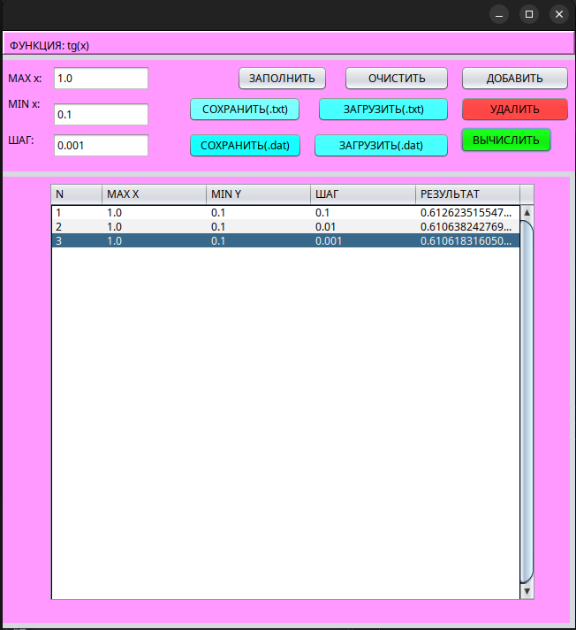
Нажатие кнопки Сохранить.txt. Первая точка остановки, фунция JButton6ActionPerformed(...).
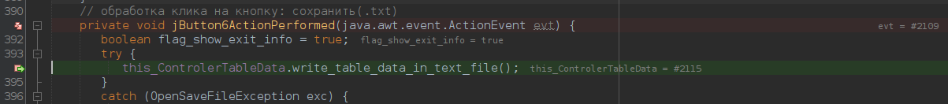
Окно работы с файлами. Вторая точка остановки , метод write_table_data_in_text_file() данные записаны :
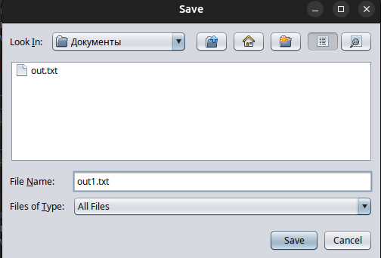
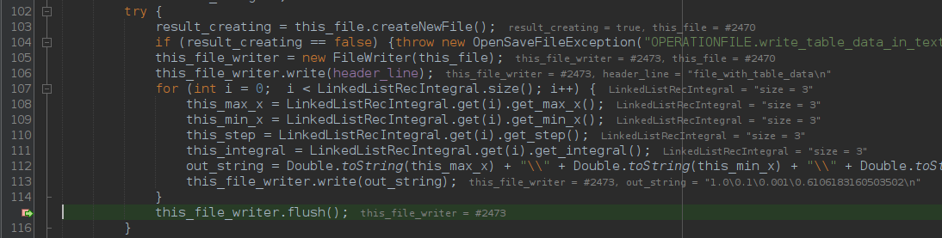
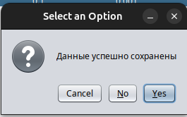
Нажатие кнопки Загрузить(.txt). Третья точка остновки, JButton8ActionPerformed, обработка исключение, после выполнения функции видим сообщение:
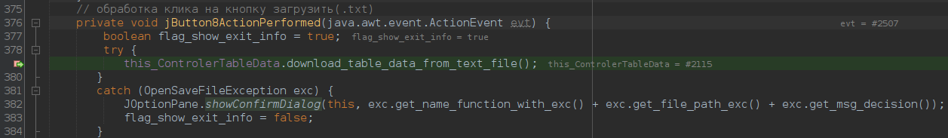
Окно работы с файлами. Четвертая точка остановки, методо download_table_data_from_text_file(). Итоговое содержание окна приложения:
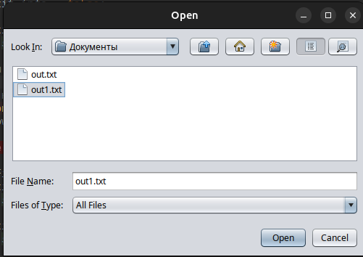
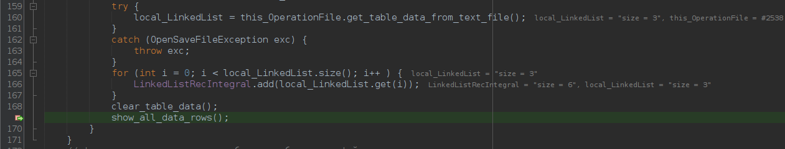
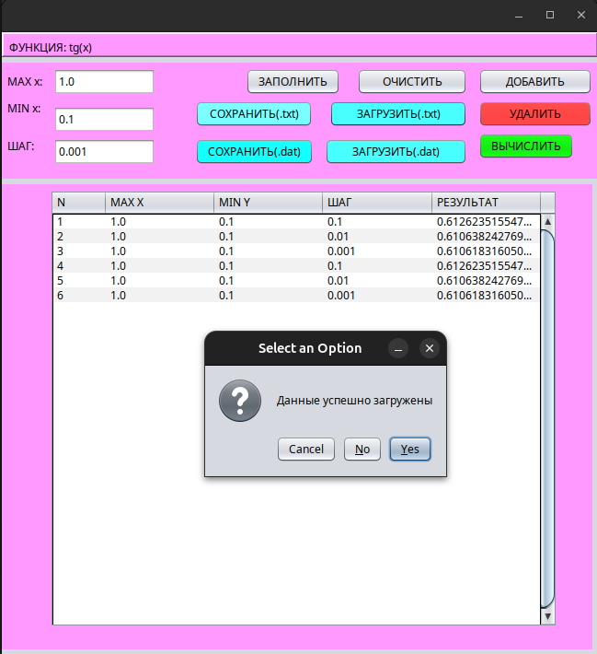
Нажатие на кнопку Сохранить(.dat). Пятая точка остановки фунция JButton7ActionPerformed(...).
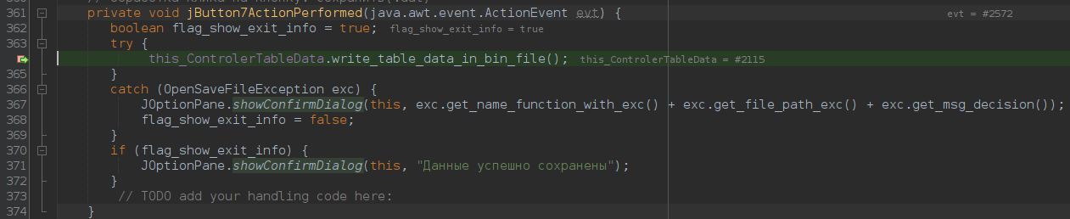
Окно работы с файлами. Шестая точка остановки, метод download_table_data_from_text_file(). Итоговое содержание окна приложения:
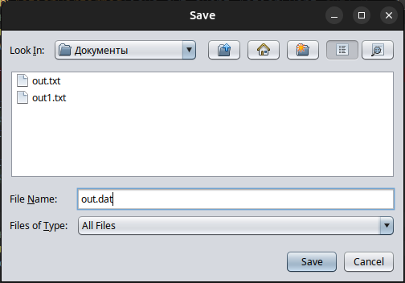
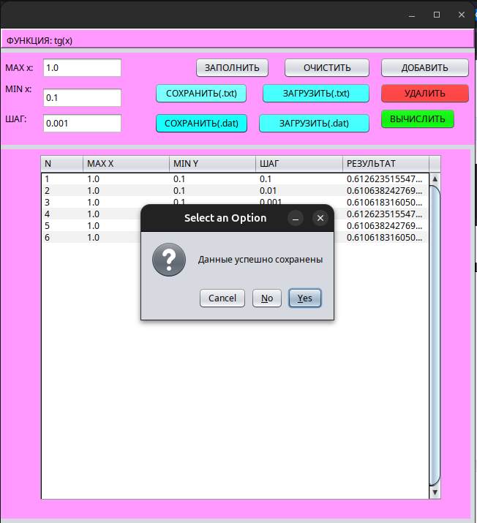
Нажатие на кнопку Загрузить(.dat). Седьмая точка остановки фунция JButton9ActionPerformed(...):
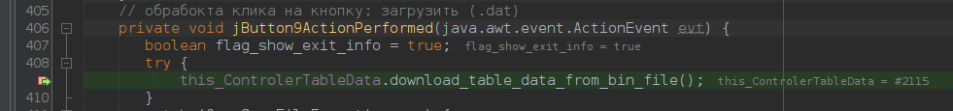
Окно работы с файлами. Шестая точка остановки, метод download_table_data_from_bin_file(). Итоговое содержание окна приложения:
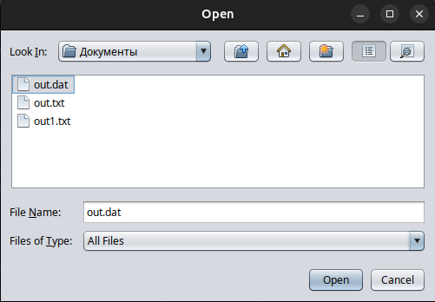
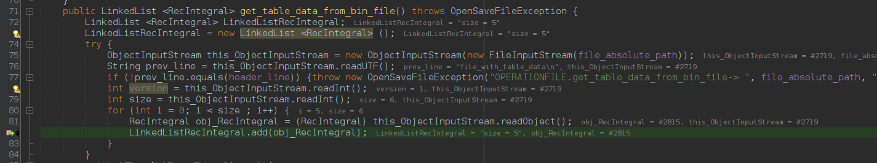
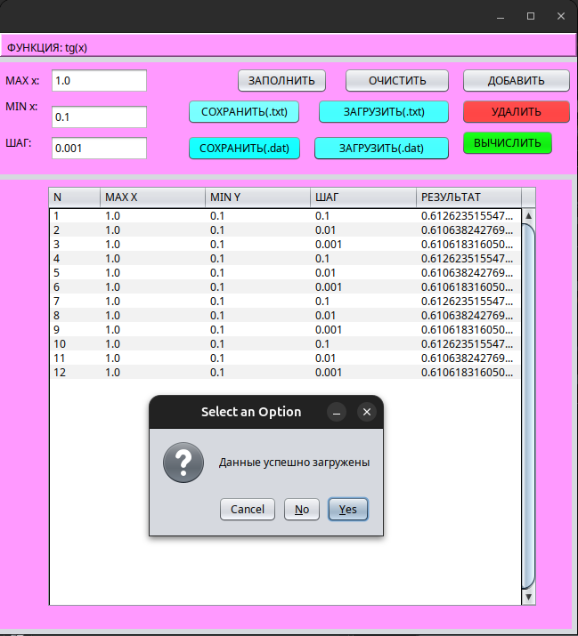
Выводы: В резульате выполнения лабораторной работы познакомились с работой над файлами бинарного и текстого типа. Изучили механизмы сериализации и десериализации для работы с бинарными файлами.

